Birmingham Bloomfield
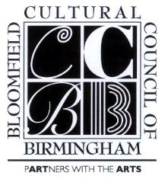
Cultural Arts Award
Nomination Form
2017

Nomination for a literary, visual or performing artist, volunteer, arts educator or philanthropist who has made a significant impact on our community
(Beverly Hills, Bingham Farms, Birmingham, Bloomfield Hills,
Bloomfield Township and Franklin.)

• Nomination should total no more than five pages and should be attached to this form.
• Should include letters in support of nominee from at least two people.
• Should discuss the nominee's specific contributions to the arts a (creative, volunteer, philanthropic etc.)
and explain the scope and unique quality of nominee's involvement.
• Should describe the cultural benefits to the community because of the nominee's involvement.
• May include internet links to illustrate the nomination. Links will not count towards the maximum page total.

Name of Nominee: ________________________________________________________________________________

Address: _________________________________________________________________________City and Zip____________________________

Phone: H:___________________________________C:___________________________________Email*____________________

Submitted by:

(1) | (2)
Address: | Address:
City: | City
Zip: | Zip:
Email:* | Email:*
Preferred Phone: | Preferred Phone:
*required
Nominations due by July 25, 2017
Email or fax nominations to:
marcy1fish@gmail.com or fax to 866-403-6794

This award is sponsored by:
The Cultural Council of Birmingham/Bloomfield
The Birmingham Bloomfield Art Center
The Community House
The Eccentric Newspapers

